
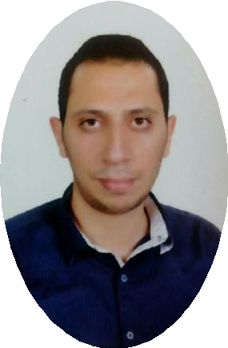
Mohamed Khairy
S A P F I C O C O N S U L T A N T
+201068187755
+97455418527
 | Mohamedkhairyshalaby @gmail.com  mos046870@gmail.com  habibayasser224@gmail.com
 | 2nd District, 6 October City, Giza, Egypt.

 O b j ect iv e
Seeking a position as an active and involved accountant and marketing specialist in many companies. Seeking a challenging and rewarding career as SAP FICO Consultant in a reputed organization where I can utilize myself at optimum level. My goal is to be in the highest position I can reach. I want to explode all my skills through my work.

Professional summary

Social Information:

☒ Birth Date:3Dec 1990
☒ Marital Status: Single
☒ Nationality: Egyptian
☒ Military Status: Exempted
I have good knowledge in configuration, implementation of SAP FICO Modules.
I have good knowledge in configuration, and implementation of Oracle E-business Suite Modules.
Experience more than 4 years in Real Estate Sales and Marketing works. Capable to work with accounting software programs. Strong work ethic and commitment to integrity and accurate record keeping. Eager to join a team and help improve an organization’s financial focus.

SAP FI/CO SKILLS:

Languages
☒ Arabic mother tongue.
☒ English very good.

TECHNICAL SKILLS:

☒ ERP Package: SAP R/3 ECC6.0
: Oracle EBS, R/12
☒ Operating Systems: windows
☒ Packages: MS Office
- FI-GL: Configuring and Customizing of Enterprise structure, Financial Accounting global setting, General Ledger Accounting.
- Accounts Payable: Configuring and Customizing Customer A/c group, vendor master data, Automatic Payment Program, house bank customization and check management.
- Accounts Receivable: Configuring and Customizing Customer A/C group, Customer master data, Configuring Dunning areas and dunning procedure.
- Assets Accounting: Configuring and Customizing of Assets, Maintaining of Asset master data, Acquisitions, Retirements, Transfers, Revaluation of Assets and Depreciation Run.
- Integration: FI Integration with MM.
FI Integration with SD.
- Maintaining Controlling area.
- Knowledge on new GL Account.
- Basic knowledge in CO-PC, CO-PA, CO-PCA

E D U CAT ION :

- BSC. CERTIFICATE IN ACCOUNTING (ENGLISH) year 2013, FACULTY OF BUSINESS ADIMINISTRATION (ENGLISH), TANTA UNIVERSITY.

C ou r se s :
  - Sap finance & Control R/3 - ECC6.0
  - Oracle E-Business Suite Financial_R12.
  - Non-Banking Financial Services Industry & Preparation for Investment Manager in Stock Exchange.

S KIL LS :

Exemplary communication skills in written and spoken form. Attention to detail throughout every aspect of work.
Strong communication skills. Great exposure in dealing with clients.
Presentation skills.
WORK EXPERIENCE:

- Working as a Marketing Specialist in Al Mamalka for Investment and Real Estate Marketing (2015 - present).
- Working at Stock Exchange and Forex Markets
- Trained and Worked as Oracle Financial Consultant (April 2014-March 2015)

