Joju sreedharn 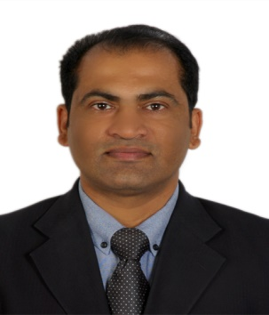
senior sales manager
20+ years of experience delivering optimal results and business value in high-growth environments in different industries across sales, key account management, and business development activities. Experience across all business channels - Wholesale, Institutional, Dealers, and Organized Retail. A manager with expertise in managing business operations across the market with a critical focus on profitability by ensuring optimal utilization of resources—Result-driven and focused with immaculate work habits, man-management, time management, and leadership skills.
Leadership  I bring over two decades of expertise in managerial roles across diverse industries. Proven success in steering sales teams, driving market research initiatives, and implementing strategic plans to meet and exceed sales targets. Adept at nurturing key client relationships, optimizing resources for profitability, and fostering team growth through effective leadership and training.  brands  Bose  Philips  Lofra  Sencor  Whirlpool  Contact  Cochin – Kerala-India  +91-956-289-6383  jojus@outlook.com  https://www.linkedin.com/in/joju-sreedhar-54710927 |  | Experience
 |  | sales manager: Ateya Trading, Ageis Medical, Redexy Web Solutions, Tadmur Trading, ashrafs, | 2011-2022
 |  | Led diverse responsibilities encompassing. Managed sales team objectives, conducted market research, and crafted strategies to fulfill consumer needs and boost company sales goals. Spearheaded sales team recruitment, training, and management. I have maintained strong client relationships, fostering connections with customers, suppliers, and partners to drive profitability. Successfully orchestrated core range distribution facilitated cross-selling, and upheld a partner portfolio for recurring business. Handled sales accountability for Whirlpool Home Appliance products in Qatar, ensuring brand visibility, revenue growth, sales forecasting, and timely delivery of products and services. Managed sales responsibilities for BOSE & Sensor Small Domestic Appliances in Bahrain, overseeing sales reporting, brand visibility, resolving complaints, and coordinating product/pricing matters.
 |  | Assistant sales manager: mohammed fakroo and brothers | 1995-2010
 |  | I led sales of Whirlpool Home Appliance products in Bahrain, driving customer acquisition, managing sales reports and forecasts, boosting brand visibility, overseeing annual sales and marketing budgets for crucial accounts, executing promotional strategies, ensuring month-on-month revenue growth, and ensuring timely product and service deliveries.
 |  | Education
 |  | Bachelor of commerce – calicut university Kerala | 1995
 |  | diploma Micro packages | 1998
 |  | other relevant information
Kingdom of Bahrain driver license: 730532208
Languages : English, Malayalam, Hindi

