
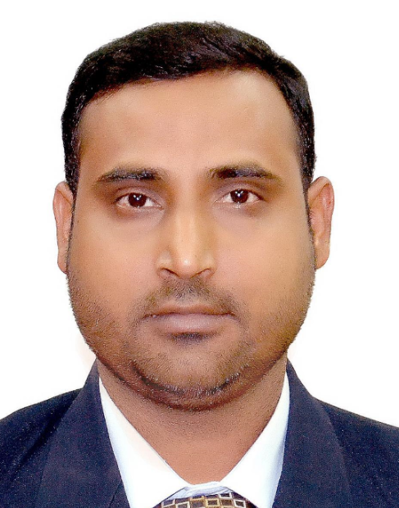
FASI HAIDER
General Manager - Operations and Projects
Visionary leader with comprehensive experience in formulating strategic plans, directing business operations and leading teams for running successful operations, engineering and projects. Actively Exploring Management positions in Middle East ,Africa and Asia.
fasihaider@yahoo.co.in 00971507032576(Dubai, U.A.E.) Skype id: fasi.haider

Profile Summary
- Goal-oriented professional with 13+years of experience in managing large scale Business and Operations in FMCG, Food Industries, Manufacturing, factories and Industrial Products business within India, Middle East & International locations
- Result-oriented Business Leader with impressive success in consistently increasing business turnover YOY by re-organizing business direction and through strategic initiatives & cost control measures
- Enhanced operational effectiveness of plants, drove process transformations, energy conservation & cost savings projects to uncover underlying issues and eliminate rejections
- Resourceful in the successful new set-up of factories; spearheading a diverse range of activities such as recruiting and training staff, establishing departments, evaluation of strategic plans, customer needs, triple constraint (Scope, Time & Cost), capacity planning, implementation of the project, process control, quality assurance, cost control and profit focus
- Track record of travelling to Italy, Netherland, Germany, Singapore, Indonesia, Philippines, Thailand, Malaysia, Nepal, Saudi Arabia, UAE, India, etc. for business purposes
- Expertise in setting budgets & driving growth in the organization by managing multiple departments and maximizing profits within a tight time frame
- Expertise in heading the Profit Centric Operations along with managing strategic relationships, market analysis & expansion, and competency development. Leader & Organizational Change Agent, delivering business results focused on improving business processes to improve reliability, increase simplicity, and enable scalable growth.
- Track record of successfully managing projects worth multimillion-dollar for setting-up factory
- Among the Top 1% in the Food/FMCG/Manufacturing and Industrial Sector professionals in the world (Industry SSI Index) as per LinkedIn Insight Ranking
IT Skills | Skill Set
- MS-Projects, MS Office Suite  - Product Lifecycle Management, Sage, SPSS  - Maximo, SAP, AutoCAD, Pro-E, Tableau, Permap  Education  - Executive Master of Business Administration (EMBA) from SP Jain School of Global Management (ranks in Forbes Top 50 list in the world.) https://www.spjain.org/  - Bachelor of Engineering (Mechanical), Rajiv Gandhi Technical University, India (2002-2006)  - IELTS – Global Level English proficiency (Scored 7.5 out of 10)  Soft Skills    Change Agent Leadership Analytical  Collaborator Communicator Planner  Time Management Negotiation Design Thinking
  General Management
  Operations Management / Projects Management
  Sales & Marketing / Business Development
  Manufacturing Excellence
  Factories Operations/ Factory/ Production Line set-up
  Maintenance Management
  Engineering Management
  Budgeting and Finance
  Team Building & Leadership
Career Timeline

Sep’17 till July 2019
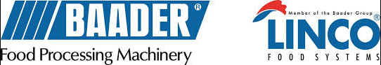
Feb’17 to Aug’17

Jul'06-Jul'08

Aug'08-Sep'10
Dec'12-Jan'17
Oct'10-Oct'12

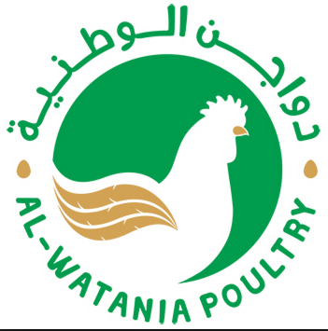

Notable Accomplishments

- Deployed various methodologies to analyse processes, recommend modifications to minimize cost escalation, realize operational efficiencies, control variability, costs & reduce cycle-time through innovative and strategic techniques in factory expenses & manpower rationalization
- Key Resource Planner with hands-on experience in planning for manpower, material and money for successful completion of projects while ensuring regulatory, quality and EHS compliance
- Directed project execution from Concept-to-Launch with focus on project scope and end-to-end solutions with a chief role in operations, capacity enhancement and technology transfer; set-up world-class manufacturing units
- Steered a team of managers, engineers & workers for production, quality, maintenance and operations; maintained effective employee relations with staff across all hierarchical levels by role enrichments, feedback sessions and disciplinary proceedings
- Led production and line rework analysis, line balancing, inventory controls, material management as per international guidelines
- Developed competency in establishing a performance-driven culture that ensures personal ownership, skilled in achieving goals as well as creating and ensuring adherence to workflow and SLAs / SOPs
- Designed solutions for key operational issues that impacted revenue and gross profit; worked closely with clients and partners to build relationships and increased business longevity and revenues
- TPM, 5S, Six Sigma and various international quality and American, Japanese, European, etc. best Practices methods implementation
Work Experience
Sep’17-Till July 2019 with Boyd International FZE, Dubai
Growth Path:
Sep'17-Mar'18: Engineering, Maintenance & Projects Manager for the Middle East and Asia
Apr'18-Jun’19: General Manager for the Middle East and Asia
Key Result Areas:
As General Manager for the Middle East and Asia
- Guiding entire project activities from conceptualization to execution including business definition, feasibility and optimization, project planning, implementation, site management and manpower planning
- Steering plant operations - set up of standards and strategic utilization and deployment of available resources to achieve organizational objectives; managing all technical and managerial aspects, developing reports on performance analysis and managing planning for better productivity
- Planning for day-to-day production, schedules and allocating work for achieving monthly targets
- Taking stringent quality measures including preparation/maintenance of necessary MIS reports ensuring compliance with objectives, standards and customer requirements
- Developing maintenance, operations procedures to increase the efficiency; implementing standards and ensuring adherence to quality standards through in-process checks
- Creating effective procedures for the preparation and implementation of programs within all area of safety, health and the environment in the manufacturing process
- Maintaining a trusted relationship with workgroup and recruited, managed and developed plant staff
- Spearheading all operations & business activities to ensure they produce the desired results and are consistent with the overall strategy & mission
- Developed & implemented standard operating procedures (SOPs) and best practices for all functions based on business as well as operational requirements for the company.
- Ensuring optimal utilization of resources of Market research agencies, Advertising Agencies, Media Agencies

Engineering, Maintenance & Projects Manager for the Middle East and Asia
- Worked as Engineering, Maintenance and Projects Manager for middle-east and Asia
- Coordinated the set-up of factories, machinery installations and upgrades of production lines in Food Industries for various companies in the Middle East and Asian Countries
- Led the team for various ongoing projects of the company, interfacing with the Sales team by supporting with technical assistance, and helping to Bid for various projects
- Devised various Standard Operating Procedures (SOPs) and best practices for all functions
- Steered project & program management for all Types of Engineering Project running across the organization including installation, testing & commissioning and finally turning it into operations
- Facilitated the valuation of buying the second-hand or new factory lines

Feb’17 to Aug’17 as Project Management Consultant with Baader Linco Asia Pvt. Ltd., Singapore
Work Type- 6-month Contract
Significant Accomplishments:
- Worked as Project Management Consultant for Asia region; coordinated with Asian Countries for various Projects management and to Regional Head Office in Singapore
- Monitored the Goods delivery, resources and manpower availability across Asia region
- Supported the Sales team with arranging proper quotations and drawings for the team based in Malaysia and Singapore

Dec'12-Jan'17 as Engineering, Maintenance & Projects Division Head at Al–Watania Poultry, Saudi Arabia
Significant Accomplishments:
- Spearheaded day-to-day engineering & Projects activities
- Managed expansion projects for the processing plant for the largest company in the Middle East, and one of the largest poultry companies in the world through a team of 100+ technicians, helpers, welders, supervisors and engineers
- Successfully upgraded processing line from existing 6000 birds/ hour to 12000 birds per hour
- Efficiently contributed to the expansion of processing plant from slaughtering of chickens from 650,000 birds/day to 850,000 birds per day slaughtering
- Spearheaded the set-up of:
- New Poultry Processing Plant with two lines, each of capacity 7200 birds per hour from scratch to final handover
(Project Cost – 40 million USD)
- Largest Bulk Grain Handling project of 160,000 tons capacity in the Middle East with 8 silos of 15000 tons capacity each and 2 soya sheds of 20,000 tons capacity each; Loading and unloading capacity of 1000 tons/hour
Project Cost – 120 million USD
- Feed Mill with 75 tons/hour production and storage capacity of 80,000 tons of raw materials and 6000 tons finished product. Project Cost – 40 million USD
- Slashed plant breakdown time by more than 90% and enhancing machine productivity with an increment of A Grade's chickens from B Grade Chickens

Previous Work Experience
- Oct'10-Oct'12 as Sr. Mechanical Engineer at Guardian Industries, Al Jubail, Saudi Arabia
- Aug'08-Sep'10 as Senior Project Engineer with Tata Motors Limited, Pune, India
- Jul'06-Jul'08 as Product Development Engineer with John Deere, Pune, India

Volunteer Experience
- 1998-2008- Member - Help Age India - Leading charity in India working with and for disadvantaged elderly
( https://www.helpageindia.org/ )
- 2008-2010- Provided free coaching for the underprivileged children in the slums and poor localities of Pune, India and motivating them to dream high and achieve high in life
- Wrote many business articles on Corporate Finance, Business Economics, Business Research, Personal Effectiveness, futuristic business& technology, etc. on LinkedIn and for online NGO magazine
- Participated in various speech competitions in Toastmasters International (https://www.toastmasters.org/)

Personal Details
Date of Birth: 12th December 1984
Languages Known: English, Hindi, Urdu & Arabic
Nationality: Indian
Passport Details: P6309822 valid till 2027 issued from Indi
Driving License: India, UAE and Saudi Arabia

