+

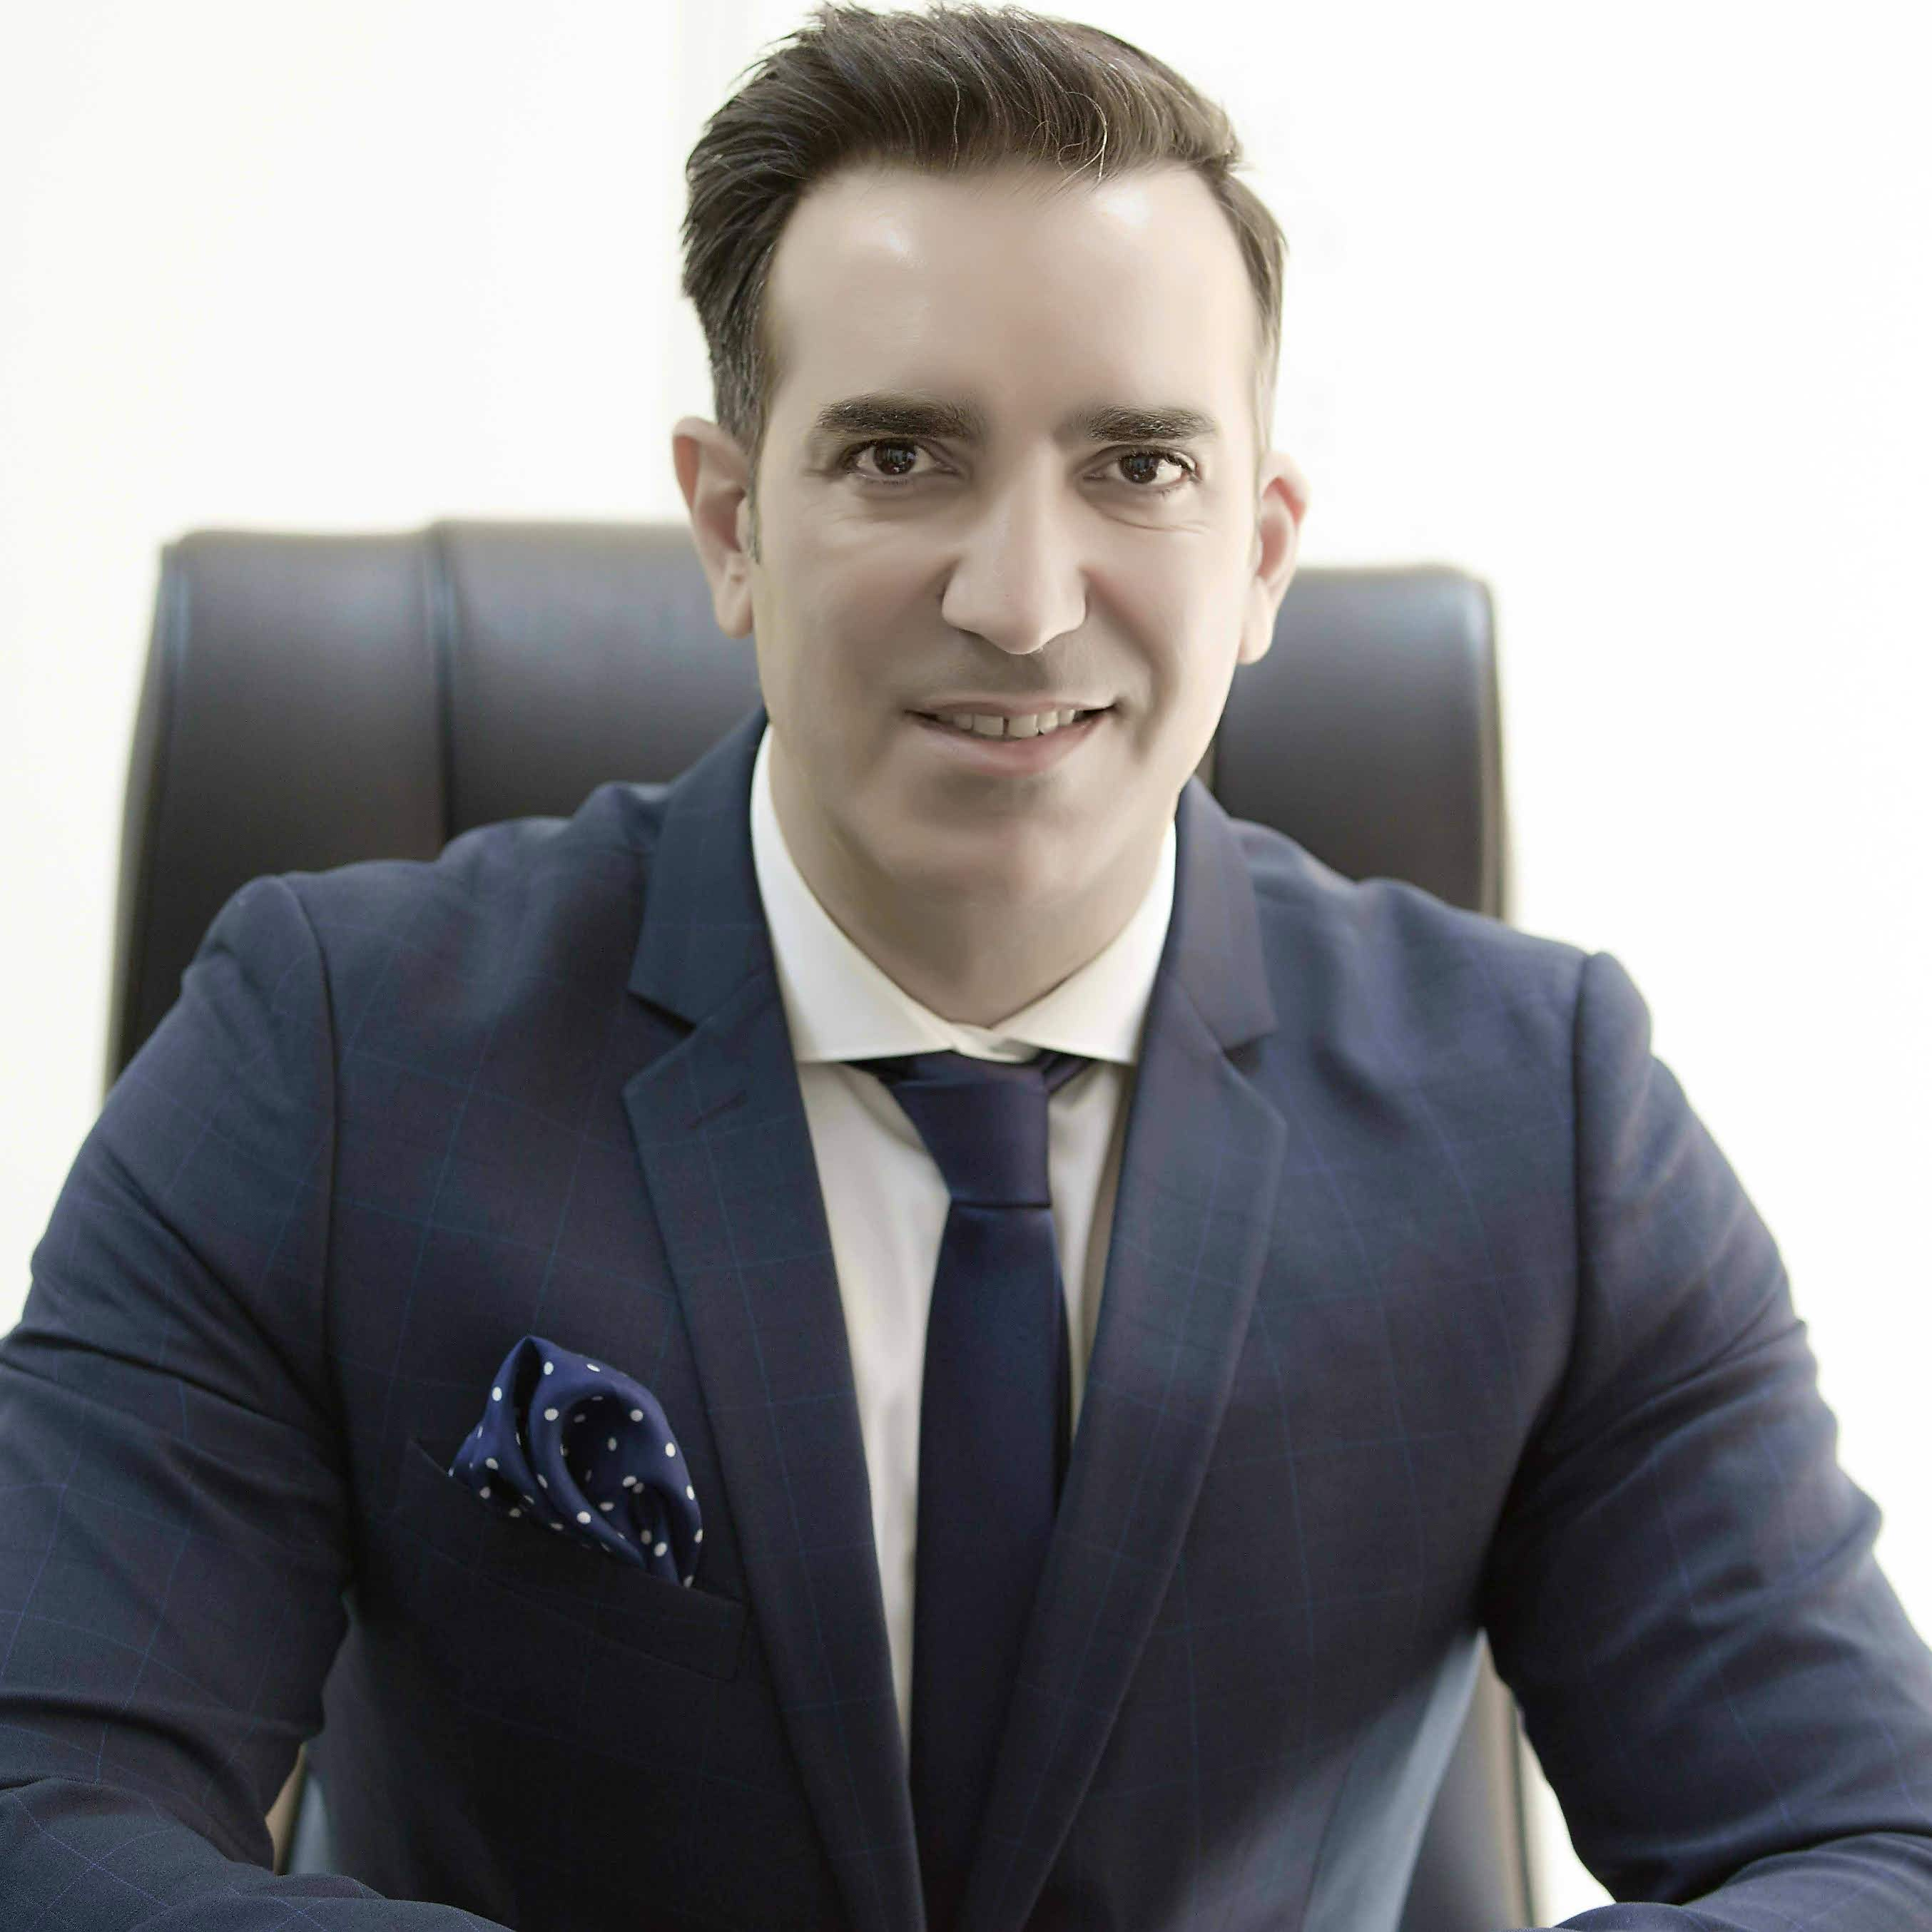

Education

Postgraduate Executive Program in Business Administration (With Honors)
Hellenic Management Association – Greece, 2002-2004

Bachelor in Business Administration
Hellenic Open University – Greece, Pursuing

Professional Development
- TOEIC® Certificate, Competency in Business English for International Communications, Hellenic American Union, Dec 2013

Andreas Argyropoulos
+971 529 271 143
argyropoulos.andreas@yahoo.gr
Dubai, UAE

General Manager 2017 – 3/2019
Kingston Holdings FZC (Glen Dimplex ME & GP Batteries ME), Dubai, UAE

Kingston Holdings Group is involved in Manufacturing, Regional Distribution and Joint Venture. Multinational Companies under JV co-operation are:
Glen Dimplex: Home Appliances (MORPHY RICHARDS), Professional Appliances (BURCO), Medical Appliances (LEC), Ventilation HVAC (XPELAIR & O.ERRE), Heating/Hot Water Solutions (REDRING).
GP Batteries Middle East: Consumer and industrial Batteries.
We manufacture REXTON: UPVC & Metal Building Materials. Distribution Ansell: Lighting Products

Accomplishments:
- Head-hunted to lead operations $ 18.5M in 30 countries and regions including the Middle East, India, Pakistan, Levant, Africa and Europe.
- Provided inspirational leadership and strategic vision to take the multinational companies onto the next stage. As Group General Manager, dedicated 80% of my time to multinational companies of Group’s activities and 20% to products we manufactured and distributed.
- Played an integral role in the continued growth of the company. Reported to The Group’s Chairman and MD, to Glen Dimplex Board in Ireland and to GP Batteries Board in Hong Kong.
- Under my leadership Glen Dimplex ME attained +11% Turnover / + 12% Net Profit and GP Batteries + 27% Turnover / +11% Net Profit (2018 Vs 2017).
- Leveraged extensive experience in driving domestic appliance business (Acquired during stint at MIELE and SAMSUNG) for globally recognized brand Morphy Richards.

Key Responsibilities:
- Defined business strategy, P&L roadmap, delivered revenues/profits by efficiently allocated financial and human resources for optimum and efficient utilization to achieve maximum profitability and goals.
- Established the long-term business strategy for the Group by setting KPI increasing the Gross Profit, to achieve the Net Profit targets, propel annual turnover & new business development.
- Conceptualized strategic blueprint for the business, formulated strategies, commercial policies, led business planning, ascertained scope and potential avenues for business growth.
- Established benchmarks and metrics to measure and evaluate effectiveness of departmental performance; Groups’ supply chain, purchase & inventory processes/procedures and demand planning
- Established expense guidelines and streamlined budgets to ensure smooth cash flow. Maximized the efficiency of both operation processes and employees’ performance.
- Participated in monthly board meetings for the evaluation of company performance.
- Owned the OPEX agenda, managed debtors and creditors and guaranteed effective cash-flow to meet short- and long-term operational needs.

COO, GM, MD, VP, CCO, Director, Commercial Director

Operations
Re-engineering
WORK EXPERIENCE
Executive
Leadership
Business Excellence

Thought Leader
Target Setting & Achievement
SIGNATURE STRENGTHS
A seasoned executive management professional with unprecedented history of P&L leadership and 20+ years of expertise in spearheading sales and operations management across the FMCG, F&B, Commercial / Industrial Products and Consumer Durables sectors.
Characterized as a visionary strategist, propelling commercial growth, proffering dynamic leadership to exceed goals and targets.
Mastered optimizing distribution, execution and operations initiatives, directing resources to achieve key sales, operations, commercial & profit objectives versus the defined business plan.
Custodian of Budgets and P&L. Shouldered onus to generate measurable ROI from available budgets to drive strategic success.
Proven track record ranges from handling a high-volume retail distribution environment, building strong distributor/partner and customer relationships to delivering monthly top line and gross margin targets.
Strategic Planning
Business Strategy Orchestrator
P&L and Performance Improvement
Executive Management
Sales Champion
Operational Leadership
PROFESSIONAL STATEMENT
Country Head (Qatar) 2015- 2016
SAMSUNG SGE, Dubai, UAE

Accomplishments:
- Shouldered responsibility for successful delivery of commercial performance/ P&L accountability for Qatar. Acted as a catalyst in evolution of business excellence for home appliances.
- Presided over day-to-day operations, for the Country with annual turnover of $ 22M.
- Empowered the sales team to achieve both qualitative and quantitative sales targets, thereby augmenting sales by 8% in 2015.
- Steered commercial performance by nurturing synergistic business relationships with the key Qatar distributors to boost the annual both turnover and profit.
- Employed key insights for turning vision into reality - accelerate growth and propelled company’s market share by 2%, sales by 8% and gross profit by 2%.
- Shouldered commercial accountability allocated annual Budget in terms of gross-profit objectives; scheduled expenditures and efficaciously mitigated cost by 4%.
- Curtailed risk expanding the company’s function in 2 new sales channels.
Key Responsibilities:
- Provided vision, headship and management oversight required to deliver excellent business results and achieve Profit & Loss/Sales target and Sales Budget goals.
- Superintended entire team of Operations, 3 Sales Managers KAM, B2B and BDM provided training, motivation & supervision by setting KPIs, prioritized the pipeline and forecasted annual sales volume.
- Offered game-changing insights for resolving challenges and enhancing bottom-line. Analyzed market trend, evaluated competitors and established sales plans based on product mix, prices and manage the ROI. Reported to the Vice President.

Sr. Business Development Manager 2006 – 2015
MIELE, Dubai, UAE

Accomplishments
- Instrumental in augmenting the gross profit in the Gallery from 22% to 25% and from 10% to 12% in the projects.
- Registered explosive growth, exceeded AED 10M a whopping 10% increase in annual turnover.
- Accredited with multiple promotions for outstanding performance and expanded the region by 1/3 of Greek market. Hand-selected to relocate in Dubai to support company’s business expansion.
- Dexterously managed a turnover of € 4.6M in IR and € 8M in OR market.
- Consistently achieved sales annual increase of 14% in 2006-2009 (prior to financial recession).
- Endeavored to build a world class business management function, took ownership of operational enablement and control of business including finances, operational processes and forecasting.
- Setup the Professional Appliances Division.
Key Responsibilities:
- Facilitated niche market development and expansion through B2B and B2C sales for Home Appliances, Professional Appliances, After Sales Service and Kitchen Furniture Divisions.
- Orchestrated annual business and operational plans, determined strategy, budgets, competition, positioning, investments, people and skills.
- Assumed full P&L responsibility and growing all economic measures dramatically. Periodically conducted Profits and Revenue Analysis. Reported to the Managing Director.

Area Sales Manager 2002 - 2006
MARS HELLAS, Athens, Greece

Accomplishments:
- Defined area business strategy and yearly operating plans. Identified new business opportunities in selected markets and aggressively steered sales.
- Led the sales team to bag key 175 agreements/contracts of € 2.6M in IR and € 6M in OR market.
- Successfully managed the National S/M key account clients and reduced annual promotion budgets ranging from 5% to 3%; expanded their purchases from €500.000 to €600.000.
- Managed internal & external stakeholders including distributors, local retail & international clients.
- Headed a team of 3 Sales Managers to manage 3 industry segments-chocolate, pet care & food.
- Steered operational excellence, transformation and developed a high-performance culture.

Sales Manager– Distribution 1999 - 2002
HEINEKEN HELLAS, Athens, Greece

Joined Business Dvpt. Manager, moved on upward career trajectories to the position of Sales Manager– Distribution with additional responsibility to manage 22 distributors in 9 counties of Southern Greece.
Designation Chronology:
- 2000-2002: Sales Manager– Distribution
- 1999-2000: Business Development Manager
Accomplishments:
- Successfully introduce 2 new brewing products in multiple industry sectors (HO.RE.CA, Retail Store Supermarkets).
- Attained stellar territory profit margins/ sales expansion from €16million to € 20,2M.
- Achieved new products distribution growth in distribution channels of 100% within 2 years.
- different shareholders and different SPAs
Handled accounting of the capital lease of QG2’s 14 mega LNG ships
PRO SKILLS
Team Development/ Management
ROI / Cost Optimization

Financial Acumen/ Budgeting
Industry Leadership
English
Greek
LANGUAGES
Executive Vision & Direction

Nationality: Greek, EU

Date of Birth: 4th October 1976

PERSONAL DETAILS
Strategic Management

