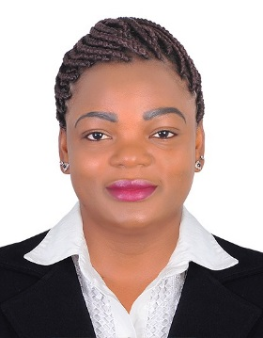
Afungchwi bridget a

Sales Coordinator
- Email: bribabyafu9@gmail.com
- N0:+971522258587(what Sapp only)
- Visa Status: Resident
- Language: English and French

PROFESSIONAL SUMMARY
Dedicated sales coordinator with 5+ years’ experience in the sales environment. Looking to obtain a position in which I am given the opportunity to play a direct role in the unlimited growth and success of the company.
HIGHLIGHTS
- accept feedback
- proactive
- integrity
- accuracy
- multitasking
- self-starter
- Great customer service skills
- Excellent communication skills in both English and French
PROFESSIONAL EXPERIENCE
Sales Coordinator/Event planner — CMI Travels $ Tourism Dubai

• Select the correct products or assist customers in making product selections, based on customers' needs, product specifications, and applicable regulations
• Make frequent calls in order to sell company's goods
• Contact new and existing customers to discuss their needs, and to explain how these needs could be met by specific products and services.
• Demonstrate the functionality and practical applications of company products
Achievements
- Gain a good number of clients from Africa visiting UAE through our services

Sales/ Cashier — Aswaaq Mall
11/2016-11/2020

• Greet and welcome customers
• Assist customers in their shopping experience
• Scanning products, collecting payment, counting money from the cash drawer, comparing receipts with revenues and solving customer inquires
• Packing customer’s bags and giving them a friendly goodbye ‘THANK YOU, COME AGAIN’

Customer Service/Sales Coordinator — Homecare Ltd Yaounde Cameroon
06/2010 — 2015
• Emphasize product features based on analyses of customers' needs and on technical knowledge of product capabilities and limitations.
• Assist customers with purchasing an exact product which best suits their needs
• Select the correct products or assist customers in making product selections, based on customers' needs, product specifications, and applicable regulations
• Focus on reaching set goals and benchmarks
• Calling prospective clients
Achievements
- Generated over 50 clients and approximately 800,000 thousand francs in sales within 4 months
- Received Top Sales Coordinator Award. Among 8 sales coordinators, was chosen by an 18 person management staff for having the ability to take initiative and lead on arrange of projects
EDUCATION
LL.B/Laws — University of Buea — Bachelor of Laws
2005 — 2009

HND Bilingual Secretary Ship – Intensive Vocational Training Center
2012—2014

TECHNICAL SKILLS
  Microsoft Word | ••••••••••
  Microsoft Excel | ••••••••••
  Microsoft PowerPoint | ••••••••••
  Sales flare | ••••••••••

